SQL Command Practice:

SELECT * FROM `students`
SELECT * FROM `students` WHERE 1

- Return all columns from the students table

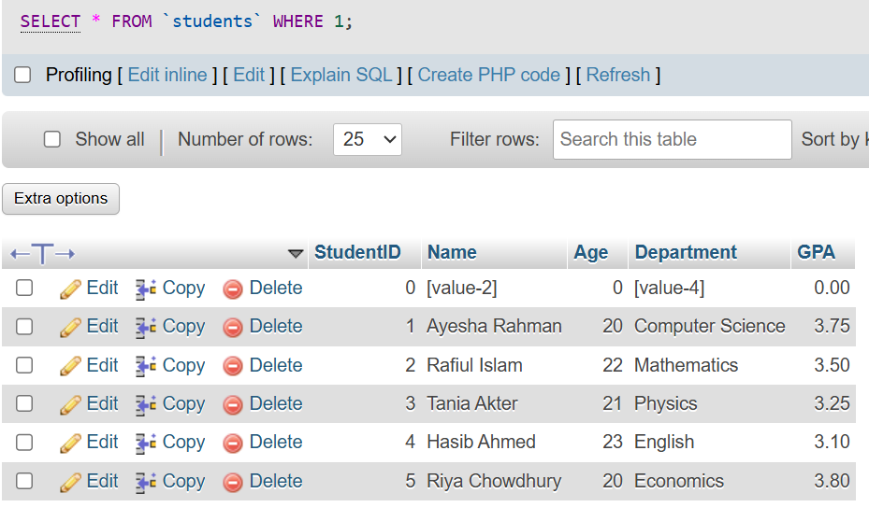

SELECT DISTINCT Age FROM `students` WHERE 1

- Show age
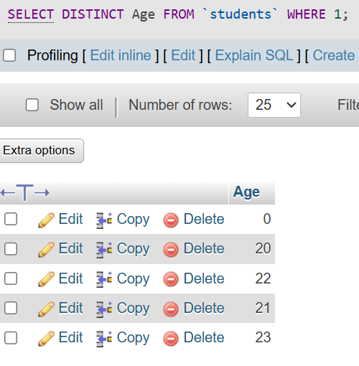

SELECT DISTINCT Department FROM `students` WHERE 1

- Show department
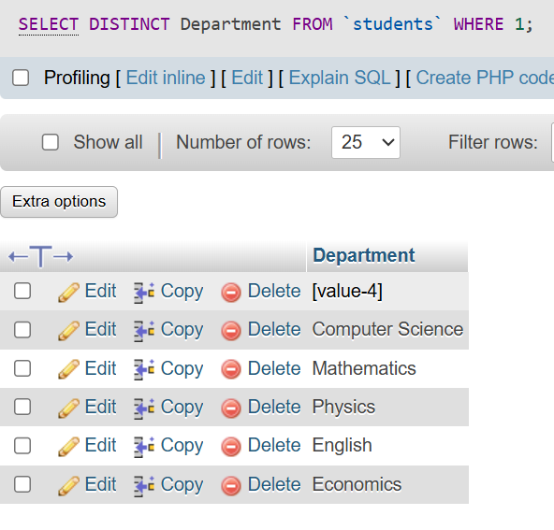
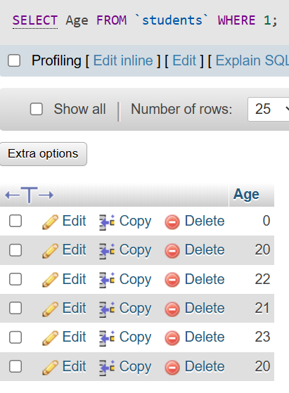

SELECT * FROM `students`
WHERE Department='Physics';

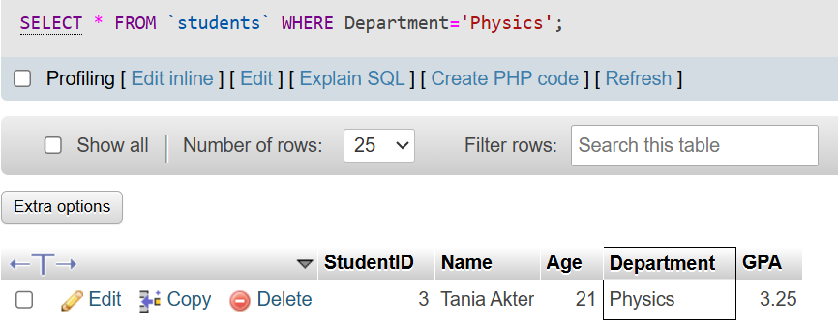

SELECT * FROM `students` WHERE StudentID=1;
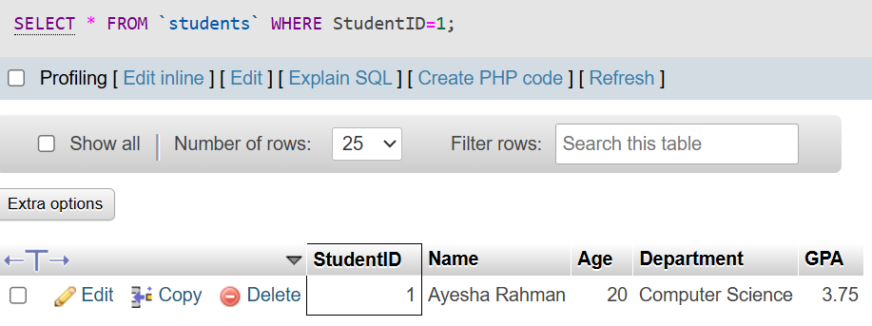
SELECT * FROM `students` WHERE StudentID>1;

